REMOTE SENSING APPROACH TO MANGROVE FOREST DYNAMICS AND CAMEL GRAZING LINE FORMATION IN COASTAL PORT SUDAN

Buho Hoshino*¹, Hiroshi Nawata², Kento Tani³, Abdelmoneim Karamalla Gaiballa⁴
¹ College of Agriculture, Food and Environment Sciences, Rakuno Gakuen University
Email: aosier@rakuno.ac.jp

² Graduate School of International Resource Sciences, Akita University, Japan
Email: nawata@gipc.akita-u.ac.jp

³ Otsuka Pharmaceutical Factory, Inc. Japan
Email: Tani.Kento@otsuka.jp

⁴ Faculty of Marine Sciences & Fisheries, Red Sea University, Sudan
Email: gaiballa4@yahoo.com

*Corresponding author: Buho Hoshino (aosier@rakuno.ac.jp)

KEY WORDS: Camel grazing line, Port Sudan, Remote sensing of mangrove, Satellite tracking

ABSTRACT: The Red Sea of Sudan is known for its fascinating and unspoiled nature, including mangroves and coral reefs. Mangrove stands are important coastal habitats, providing fodder, wood products, fish breeding grounds, and camel grazing areas. Originally, vast stands of mangroves existed where seasonal streams reached the shore to create the brackish and sediment-rich conditions necessary for mangroves to thrive. Camel lines are a phenomenon in which trees below the average height of a camel (approximately 2.20 meters) or the height of a camel (3.0 meters) are all eaten and killed, leaving only the upper parts of the camel's body. As a result, trees are left to form the eaves of buildings along the Red Sea coast. It should be emphasized, however, that the camel line, which is caused by camel eating damage, is formed only when plant resources are extremely scarce. Today, mangrove forests are severely threatened throughout the coastline due to climate change, overgrazing and overcutting, and in some areas, destruction by coastal industrial development. This study aims to determine the effects of climate change and camel grazing on dynamic changes in the mangroves of Port Sudan on the Red Sea coast. Time-series Landsat satellite data were used to extract changes in mangrove area. Satellite tracking of camels also revealed feeding damage to mangrove forests by camels. Optimization of grazing would increase plant biomass production. The saplings were protected from camel feeding damage by an artificial channel created in 2000. This expanded the distribution of mangrove forests in the offshore direction of Kulanayeb. However, optimizing camel grazing did not reduce the distribution of mangrove forests, and it is assumed that the NDVI values in such areas show a high index.

Introduction
Camels are adapted to arid-region environments and can use salt plants, hard shrubs with thorns, and tall trees as food (Schmidt-Nielsen, 1959; Wu et al., 2014; Watson et al., 2016).
They also could convert these plants into meat, milk, and other tissue cells. Because of this amazing ability, camels are the only animal in Africa and the Middle East that has minimal problems with food shortages, even though there appears to be almost no plants for livestock to feed on (Yagil et al., 1980; Wilson et al., 1990; Ben et al., 1993; Guliye et al., 2000; Wernery et al., 2006; Bekele et al., 2011; Dahlborn et al., 1997; Dahlborn et al., 2000).
In this study, we discuss the feeding habits of camels in arid lands and how they find food from the desert and seashore. Along the Red Sea coast of Sudan, camelids devour acacia and mangrove forests, creating a unique landscape known as the "camel line”. Using the camel line as an example, this paper examines the impact of the dromedary camel on the natural environment of the dry tropical coastal zone. Coastal zones of the arid tropics are defined as semi-continuous coastal areas where arid land meets with mangrove and coral reef areas of tropics/sub-tropics. This stretch from East and Northeast African countries, Red Sea countries, Arabian and Gulf countries to India sub-continent along seashore edges of the Afro-Eurasian continents. In these zones, mangrove ecosystems of Avicennia marina as dominant species and coral reef ecosystems of fringing reef interact each other (Nawata 2005). From the viewpoint of plant and animal net production and biomass, the coastal zones of the arid tropics are characterized as the zone where the most unproductive land ecosystem and the most productive sea ecosystem come into contact with each other (Nawata 2013). Mangrove ecosystems in the coastal zones of the arid tropics can be an important source of energy for the surrounding terrestrial ecosystems. Mangrove productivity (litter-fall) is as much as ten times higher than the surrounding desert zones (approximately 1-ton d.w. ha-1 year-1) (Whittaker & Likens, 1975; Myers, 1984), and part of this high productivity can flow from the mangroves into the adjacent terrestrial ecosystem through livestock feeding (Flores-Verdugo et al., 1993). As, in most situations, more energy and materials flow through detritus food webs than through grazer food webs (Schleyer, 1986; Mann, 1988), the use of mangrove foliage for livestock feeding is an interesting phenomenon in terms of material circulation between land and sea (Nawata 2013).
For Sudanese herders, camels are an important asset to support their families (Nawata 2001). The most distinctive feature of livestock grazing zones is what the camels’ grazing zone includes the space extending to coral reef islands where other livestock cannot access through coral reef flats. The one-humped camel is excellent at moving not only on the loose sandy soils of the desert but also on irregular and complicated topographies of coral reef flats. It is possible to reach the coral reef islands without a boat by riding on a camel. Any other livestock than the camels (cattle, sheep, goats, and donkeys) are impossible to walk on the bad terrain of both soft substrates (sandy beach, mudflat and saltmarshes) and hard substrates (coral reef flats and raised coral reefs) in the littoral and sublittoral zones, because of their anatomical structure. Other livestock may fall into spaces between coral reef colonies, because their feet are smaller than camels’, despite their weight being less. Camels also have enough height to stand certain degree of strong wave action and currents that other livestock and human do not have. The raised coral reef islands are utilized as grasslands and shrublands that are available only for camels, therefore can be called as an exclusive habitat or an exclusive niche for camels. An impact of human activities including camels’ feeding must be examined carefully and assessed cautiously in terms of biological resource preservation in the coastal ecosystems (Nawata 2013).
Many pastoralists have only one camel as their entire property. Since they depend on camel milk for most of their livelihood, they try to feed their camels as much fresh leaves and seeds of plants as they can. They know that feeding these to the camels produces a large amount of milk. They also lead camels to the coast to feed on the flowers and seeds of the mangrove forests, hoping that the mangroves will be in full bloom. Camel feeding experiments have proven that the leaves of saline plants (including acacias), especially the green parts, are effective in producing milk and meat. Also, as discussed below, in forests where camels forage in moderation, plant growth is more active and flourishes. However, when the seeds are eaten up, it adversely affects the mangrove forest and prevents its renewal. Camel lines are a phenomenon in which trees below the average height of a camel (approximately 2.20 meters) or the height of a camel (3.0 meters) are all eaten and killed, leaving only the upper parts of the camel's body. As a result, trees are left to form the eaves of buildings along the Red Sea coast (Ahmed et al., 1992; Costanza et al., 1997; Zeleke et al., 2001; Ahouangan et al., 2022). It should be emphasized, however, that the camel line, which is caused by camel eating damage, is formed only when plant resources are extremely scarce (Photo 1).

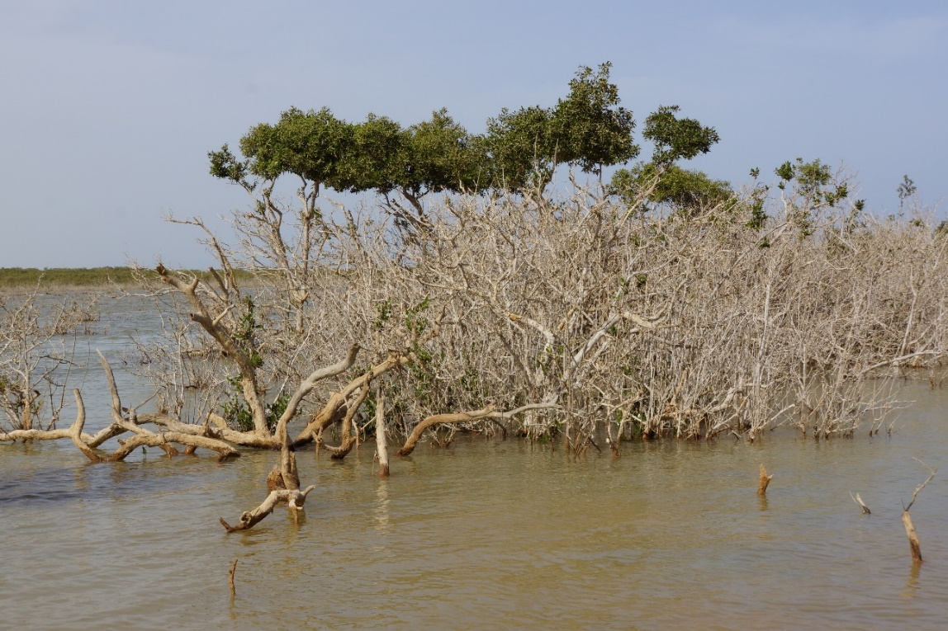

Photo 1: Camel line of a Avicennia marina in Port Sudan

Camel lines are formed in mangrove forests distributed along the coast of Port Sudan. The mangrove forests contain only one species of tree, Avicennia marina. The Avicennia marina is an evergreen shrub or sometimes a tall tree with a maximum height of more than 25 meters. It has broad horizontal roots that radiate out into the mud of mud flats, and soft respiratory roots, called bamboo shoot roots, a few centimeters high, protrude vertically from the soil surface (Friess et al., 2013; Feka et al., 2017). Seeds are produced around January and are an excellent food source for camels (Photo 1).
In many countries, Avicennia marina is listed as an endangered species, although in 2020, 113 of the world's 223 countries/regions were reported to have mangrove swamp forested areas, and the global mangrove area is estimated to be 14.8 million ha (FAO, 2020), Mangrove forests are sensitive to environmental changes, and their area decreased by about two-thirds between 1980 and 2000 due to tidal changes, sea water temperature, and global warming (Polidoro et al., 2010; Raitsos et al., 2011; Giri et al., 2015; Rafique et al., 2018; Boateng et al., 2018; Carugati et al., 2018; FAO, 2020). Mangrove forests in the coastal areas of the Red Sea are also decreasing in area due to global environmental changes, and in the study area, along the coast of Port Sudan, the camel line is further formed by camel feeding damage. But are camels only damaging to plants? In this chapter, we would like to clarify the relationship between camels and mangrove forests by analyzing the dromedary camel foraging behavior of dromedary camels.
Camelids rely heavily on semi-shrubby saltmarsh vegetation, mainly of the family Acanthaceae, and evergreen mangrove branches, leaves, and seeds for food, and these plants are classified in the category with the highest preference (Osman et al., 2019; Zanvo et al., 2021). On the other hand, the dung beetle on the coast of Port Sudan has the highest preference for dromedary mangrove forests, but the ecosystem of these mangrove forests has not been well studied until now (Nawata, 2001; Aljahdali et al., 2021). Therefore, we decided to investigate the dynamics of mangrove forests of the dromedary camelid, which is locally distributed along the coast of Port Sudan, and the actual foraging damage caused by the dromedary. The study area was in the south of Port Sudan, the capital of the Red Sea State of the Republic of Sudan, and we analyzed the ecology of mangrove forests here and the behavior of domestic dromedary camels that use these mangrove forests as a food resource. To clarify the behavior of the camels, we attached a GPS to the camels and conducted satellite tracking. We also walked with the camels on the ground and observed their behavior.

The study sites
Three mangrove forests were surveyed. The mangrove forest at site K is located approximately 8 km south of Port Sudan, while the mangrove forest at site H is located approximately 13 km south of Port Sudan. The mangrove forest at Point A is located approximately 1 km south of Point H across the channel. The houses of pastoralists who keep camels for GPS tracking are located at Site 1 and Site 2, which are about 1 km west of the mangrove forest at Site A (Figure 1). The location was divided into Site 1 and Site 2, and tracking surveys were conducted at each location.
Site 1 had 53 camels in the winter and 20 in the summer. Site 2 had 3 camels during the summer. The coastal plain from Port Sudan to the Kulanaieb region has little difference in elevation, making it possible to compare the mangrove forests at Site H, which is difficult for camels to access due to a channel built in 2000 for the construction of salt flats, with those at Site A, which are easily accessible by camels and have a large area of mangroves, This was one of the objectives of this study.
The Red Sea State has a summer rainfall pattern in the mountainous areas of the Red Sea Hills (excluding the eastern slopes) and the western plains to the west of the Red Sea Hills, while the eastern coastal plain, the study area, has an extreme winter rainfall pattern with 70-90% of rainfall concentrated in the period from November to January, and the winds are from the south during the winter due to the monsoon. In other words, the wind direction changes from southeast in winter (October to May) to northwest in summer (June to September). The highest tide level of the year is from November to April, with an average of 8 cm, and the lowest is about -15 cm in August, with a difference of 23 cm, and the daily fluctuation of the tide level is only 6 cm. The average annual precipitation in the major cities of the Red Sea State is less than 150 mm, which is less than in Khartoum, the capital of Sudan. Precipitation is also very erratic, and the Red Sea State experienced major droughts in 1954, 1973, 1981, 1984, 1985, and 1986. The average annual temperature is 28.3°C and annual precipitation is 80.2 mm.
The characteristic of the pastures in relation to livestock feeding behavior in each season are clarified: 1) livestock shows various degree of pasture utilization depending on taxon, life forms, categories such as halophytes/glycophytes; 2) half-shrub halophytes, mainly Chenopodiaceae plants, and the foliage of evergreen grey mangrove (Avicennia marina) are highly palatable for camels; 3) some grassland and shrublands are accessible and available only to camels (Nawata 2002). Donkeys, cattle, and sheep are so-called grazer and depend on various grasses of grasslands on the coastal plain and shrublands at which the surface runoff of seasonal streams terminates. More specifically, the grazing range of donkeys is limited only around the village (human living) area. On the other hand, cattle may be brought to other areas only in the summer and given roughage (straws of sorghum and pearl millet) or concentrate. Sheep, goats, and camels are herd only in this area. Goats that can browse shoot and leaf of Leguminoseae shrubs acacia often use shrublands at the inland margin of saltmarshes and shrublands with legumes at which the surface runoff of seasonal streams terminates. In this area, however, shows herding pattern that goats as well as sheep and cattle mainly graze Gramineae grasses and partly browse Leguminoseae or Chenopodiaceae half-shrubs. Goats do not prefer Chenopidiaceae halophytes except a perennial grass halophyte, Aeluropus lagopoides. On the other hand, camels rely on half-shrub halophytes, mainly Chenopodiaceae plants, and the foliage of the evergreen mangrove, Avicennia marina. Camels not only show broad feeding range for every family of plants, but also show high-level palatability on almost all species of halophytes. Especially in the summer, camels frequently use halophytes and mangroves (Nawata 2013).

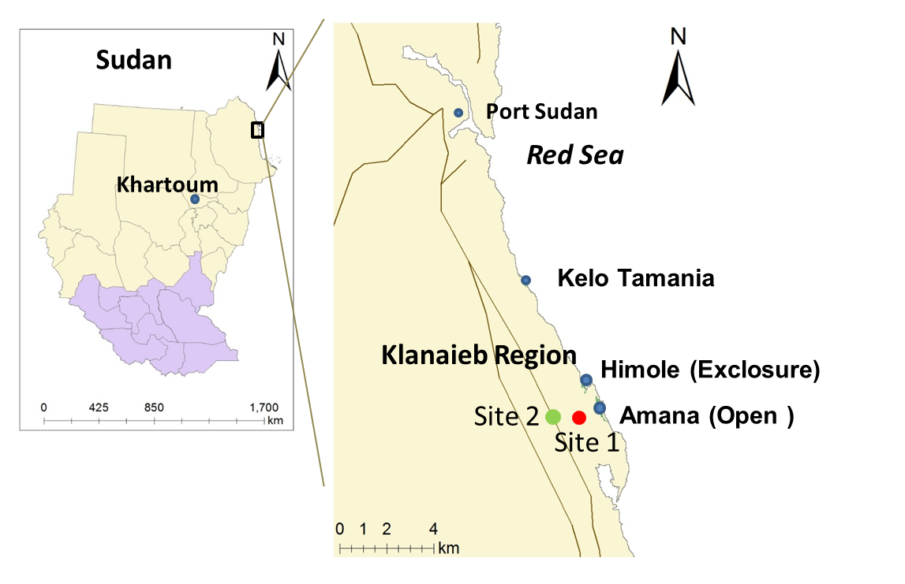
Figure 1 The study area and sites

Methodology

Measurement of photosynthetic activity in plants
To determine the degree to which mangrove forests are actively photosynthesizing, we measured photosynthetic activity using a spectroradiometer (FieldSpec-HandHeld, Ⓒ ASD). Since the data obtained included reflectance in the red and near-infrared wavelength regions of visible light, we calculated and mapped the Normalized Difference Vegetation Index (NDVI), which indicates the amount of vegetation and the degree of photosynthetic activity (Gao, 1996; Green et al., 1998; Gao, 1999; Saito et al., 2003).

Investigation of camel foraging behavior using GPS collars
Satellite tracking (GPS-attached) surveys of dromedary camels were conducted for 5 days from December 23-27, 2011, and for 11 days from August 3-13, 2012 (Figure 5). GPS loggers were attached to dromedaries in the morning before camel grazing, and data were retrieved and analyzed in the evening around 17:00-18:00 hr, when the camels were returning home from the pasture were used, and point data such as location information was set at 10-second intervals. In addition, distance, speed, altitude, and time were also recorded. In addition, video was taken every 10 minutes of camels foraging for dromedary camelids in a ground-based camel tracking (stalking) survey, and the number of leaves and respiratory roots being foraged were counted.

Results

Comparison of photosynthetic activity of five native and exotic plant species
To compare photosynthetic activity between the Avicennia marina mangrove forest and coastal terrestrial plants, we used (1) the terrestrial exotic plant mesquite (Prosopis juliflora), (2) the terrestrial saltwort hamamelis (Suaeda monica), (3) a plant distributed in the open at site A and freely accessible by camels (3) a mangrove forest with moderately eaten mangroves, (4) a mangrove forest without foraging traces on the opposite side of the waterway at site H (an undisturbed mangrove forest), and (5) a mangrove forest with a camel line formed in front of the waterway at site H (a devastated mangrove forest) (Figure 2) ).

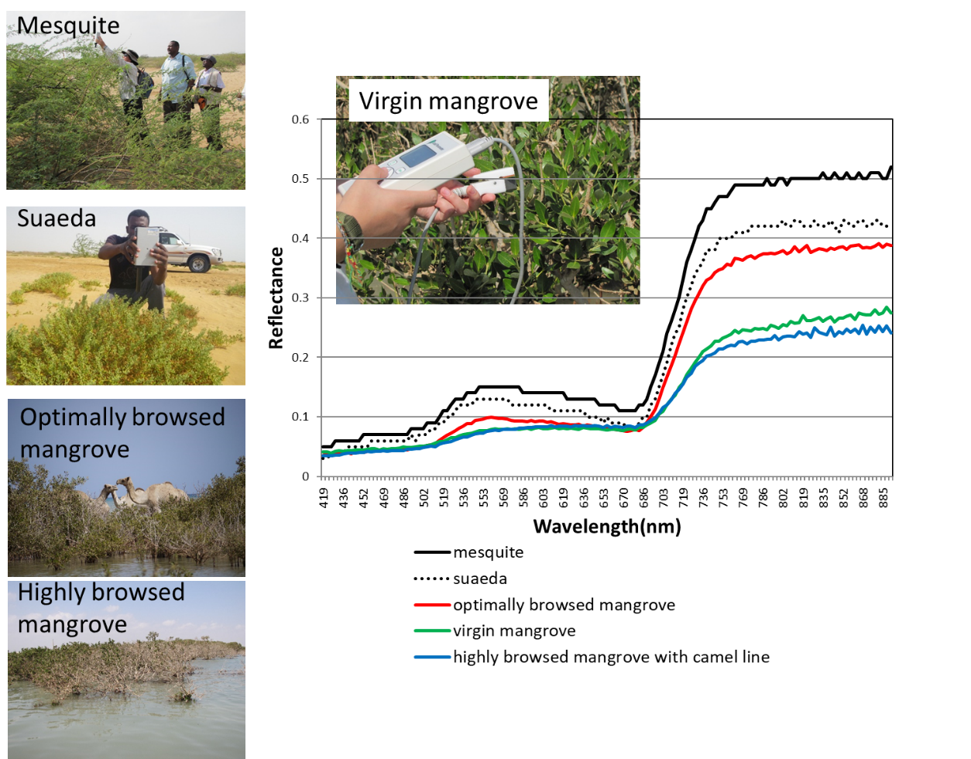

Figure 2 Comparison of photosynthetic activity of five plant species (640-770 nm). Lower values on the vertical axis near the wavelength range and higher values above 770 nm indicate higher photosynthetic activity.

The lower the reflectance in the visible red (640-770 nm) and the higher the reflectance in the near infrared wavelength range (above 770 nm), the higher the plant activity. As can be seen from Figure 2, the exotic plant mesquite has the highest photosynthetic activity. Next is the saltwort Suaeda maritima, and last is the mangrove forest. Comparing mangrove forests, the photosynthetically active site A, to which camels have free access, has the highest photosynthetic activity. This is probably since camels feed on the mangrove forest to a certain extent, causing new leaves to sprout one after another and stimulating photosynthesis.

Differences in foraging pressure in exclosure and open access areas
In the case of the Avicennia marina forest in front of the waterway at site H, camels cannot cross the waterway, so they stay longer at the local point in front of the waterway, which is thought to have formed a camel line due to overgrazing. Reflecting this, the photosynthetic activity at point H decreased, the leaves withered, lost their ability to absorb light and photosynthesize, and the difference in reflectance between red and near-infrared wavelengths shrank, resulting in a vegetation index NDVI index near zero (see Figure 2). In other words, the creation of the channel prevented camels from reaching the "pristine mangrove forest" on the other side of the channel at point H, and the mangrove forest in front of the channel became a "frequently eaten mangrove forest," forming a "camel line.
The mangrove forest at Point A, which is distributed in an open area, has a relatively large area, so even if it is eaten to some extent, leaf renewal occurs frequently and photosynthesis is considered to be most active. In the mangrove forest at site A, the "grazing optimization theory" (McNaughton 1979; Hilhart, et al., 1981; Bclsky 1986; Motoyuki et al., 2007) was established for the foraging behavior of camels (see Figs. 3~4).

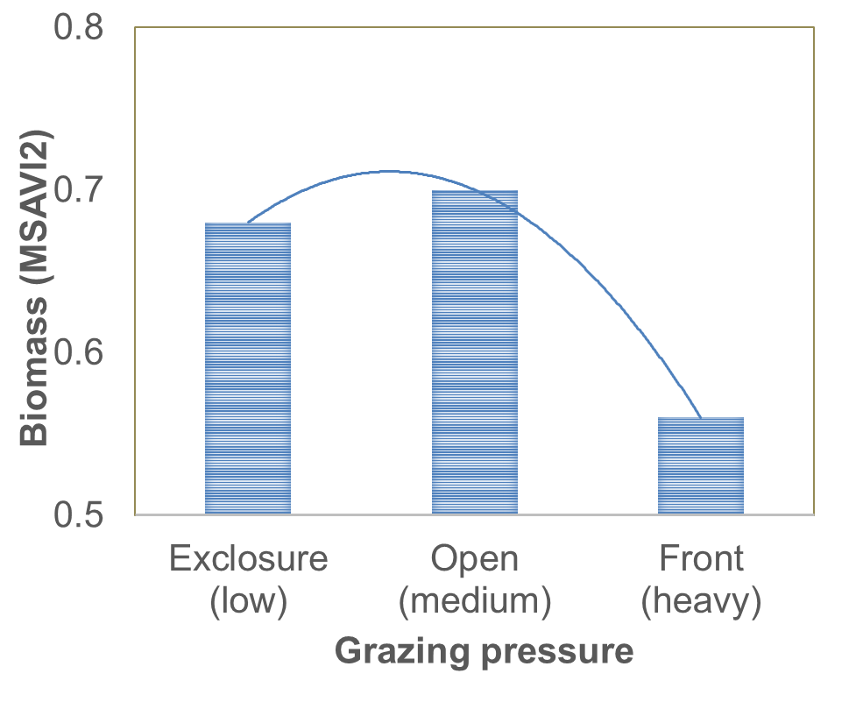

Figure 3: Optimal grazing theory (Photosynthetic activity is highest in moderately foraged mangrove forests (Open area). In other words, photosynthetic activity is stimulated in optimum browsed mangrove forests; camel lines are formed by overgrazing.

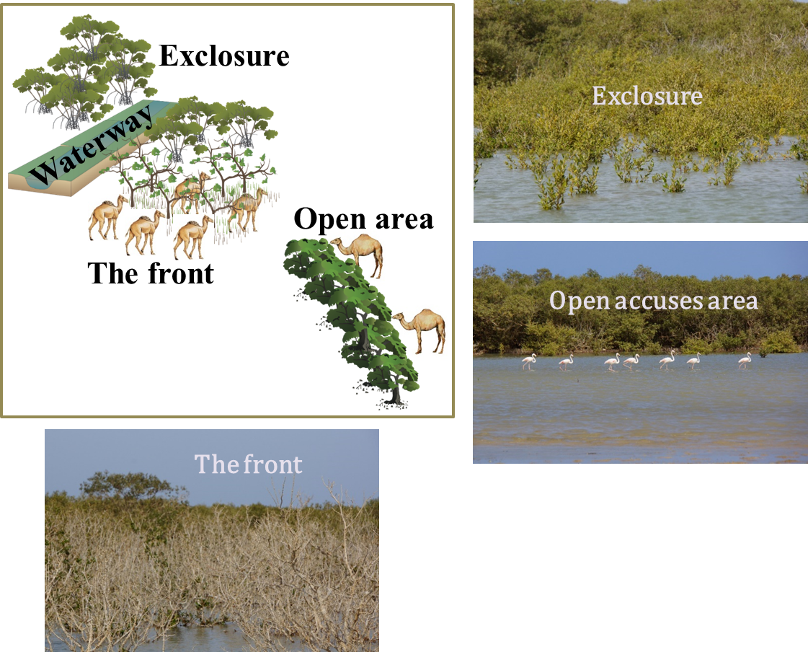

Figure 4: Formation of camel line (camel line forms in front of the channel because the channel prevented camels from foraging freely)

Foraging behavior of camels in Port Sudan
In December 2011, camels were in the mangroves for 3 days during the 5 days of satellite tracking, and the only mangrove forest they accessed was Point A. Grazing began around 7:00 AM, and the camels returned to the herders' homes around 5:00 PM in the evening. When accessing the mangrove forests, they followed the route they had taken in the past, crossing sandbars where the underwater ground was hardened, and foraging for dromedary mussels offshore. There is only one route taken when walking underwater through the sandbar. Interviews with herders also revealed that camel herds do not use underwater paths with poor footholds or paths they are not accustomed to passing. We also learned that if the waves are strong when the herders begin grazing in the morning, they do not enter the sea, but go to the salt vegetation distributed in the salt marshes along the coast, and then access the mangrove forests. During the winter season, the camel herds were observed to pass to the offshore mangrove forests almost daily to forage in the mangrove forests (see Figure 5).
In August 2012, satellite tracking of camels and tracking of individuals on the ground were conducted; in 11 days, camels had access to mangrove forests for 7 days. Compared to the winter season, they did not cross the ocean, but instead traveled overland, crossing a salt channel with a lowered water level, to a small part of the mangrove forests at sites K and H, located to the north. Because of the longer distance traveled compared to the winter season, the time spent in the mangrove forests was relatively short. Interviews with herders also revealed that during the summer season, herders rode the leader camels of the herds walking at the front and guided the herds to the foraging sites because of the long travel time during the day.

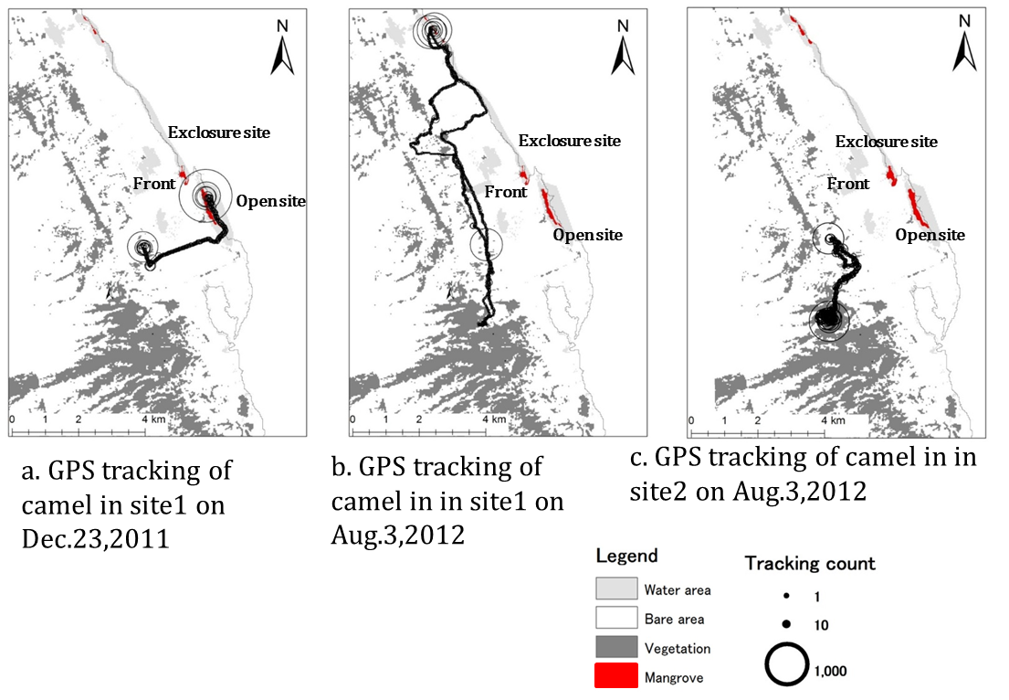

Figure 5 Distribution of mangrove forests (black areas indicate hirundo camelids (Avicennia marina); the size of the circles represent the camel GPS tracking records; (a)shows at site 1 on December 23, 2011;(b) shows at site 1 on August 3, 2012 and (c) shows at site 2 on August 3, 2012; the numbers are the number of GPS points; the larger the circle, the longer the dromedary camel stays)

We counted the time camels spent in the mangrove forest in December 2011 and August 2012, the number of leaves they foraged and the number of branches they foraged, based on video recordings. The results showed that the number of leaves and branches foraged by the Avicennia marina was greater for 10 minutes during the winter season than during the summer season. In addition, female camels that were not with their pups had the longest travel and resting time and the highest number of Avicennia marina leaves foraged.

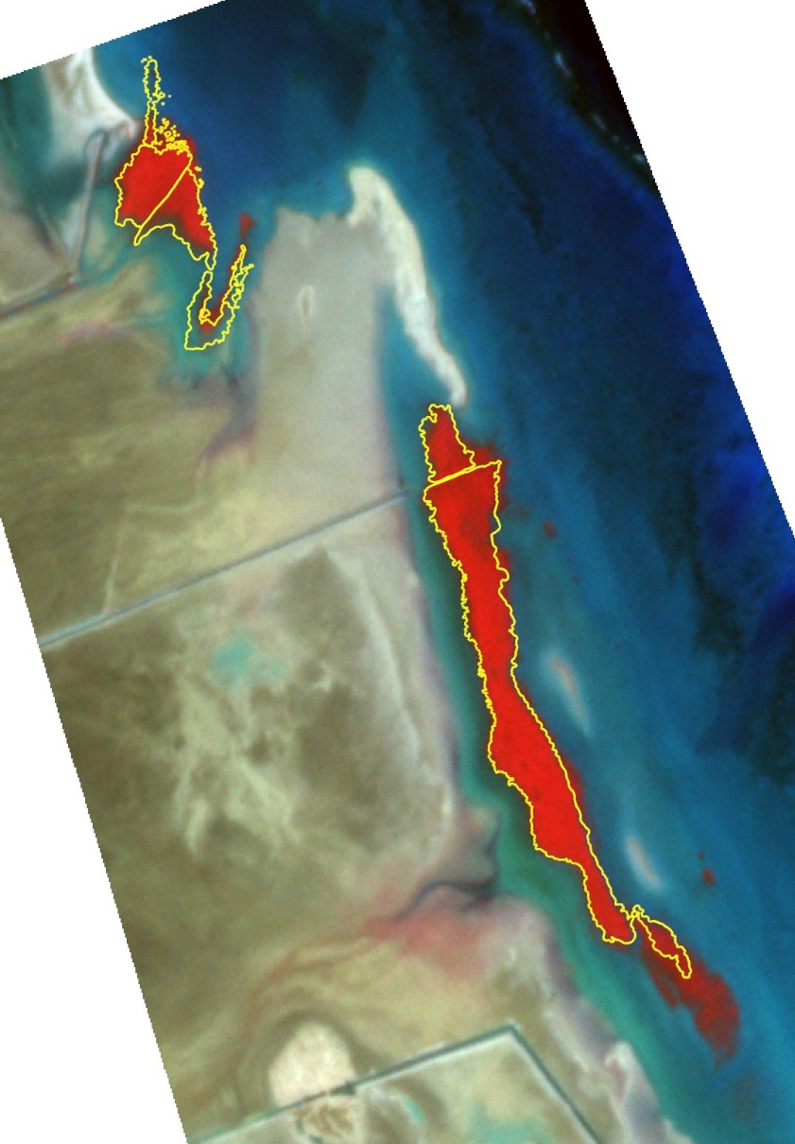

Figure 6 Mangrove Forest dynamics between 2013 and 2023 in Port Sudan

Figure 6 shows the change in mangrove forests between 2013 and 2023. The yellow polygons are mangrove forest distribution areas extracted from 2013 ©Google earth image, and the red image is mangrove forest distribution extracted from Planet Dove satellite data taken in 2023. The expansion of mangrove forests was observed in open areas (Amana site) where camels have free access. However, further shrinkage of the mangrove forest was observed in the area in front of the channel. This is a very strong test of the grazing optimization theory.

Discussions
The rates of foraging behavior of female and camelids with pups were similar. Comparing the damage caused by camel foraging, photosynthetic activity was highest in mangrove forests with proper foraging, followed by mangrove forests with no foraging, and lowest in forests that appeared to be under excessive foraging pressure. The last "excessively pressured forest" was a mangrove forest where camel lines had formed in the past (Vovides et al., 2011; Elsebaie et al., 2013; Almahasheer et al., 2016).
The only mangrove forests to which pastoralists guided their camels in the winter were the mangrove forests at Point A, which were the closest and largest in area to the pastoralists' homes, and in the summer, they guided their camels to parts of the relatively small mangrove forests at Points K and H, which were located closer to Port Sudan. The summer season in this area is the dry season, and herders take their main camels to the southern interior, where the climate is summer rainfall. However, female camels with their young, which have difficulty traveling long distances and crossing mountains, are left in coastal areas to spend the summer. In order to avoid excessive foraging by the camelids, herders move them long distances along the coast and lead them to mangrove forests that are not used during the winter season. Since camels forage more for hollyhocks in winter than in summer and spend more time in mangrove forests in winter than in summer, the camels are divided into separate seasons and moved to avoid using mangrove forests in summer for foraging in winter, as in Nomadic Herding.
It is thought that herders avoid overgrazing mangrove forests by seasonally controlling the mangrove forests where camels forage. At site H, a mangrove forest bordered by a channel created in 2000, the restriction of camel foraging has protected the juvenile trees, and their distribution has spread offshore. However, at the foraging site where camels were continuously foraging, the activity level of the mangrove forest was conversely high, and the field survey confirmed that the mangrove forest was not damaged by the appropriate foraging by camels and that, on the contrary, the renewal of vegetation was promoted. By properly grazing camels, "camel lines" do not form. In addition, "camel lines" do not easily form in areas where other plant resources are present.
Similar problems are occurring all over the world. For example, a trans-Tibetan railroad across the Tibetan Plateau has divided the habitat of the chiru (Tibetan antelope) from east to west, preventing the seasonal migration of the chiru and having a significant negative impact on its reproduction and ecological conservation (Hoshino et al. 2019). In addition, since the 1990s, settlement has been promoted in Inner Mongolia, and pastoralists have built many fences to protect their allotted land. The fences have divided the grasslands into small plots. As a result, the pastoralist style of grazing, which relied on the free movement of livestock, is no longer feasible, and livestock activities are now restricted to the limited space provided by fences. In grasslands separated by fences, livestock frequently use the same areas repeatedly, resulting in overgrazing (Na et al., 2018). Instead of livestock's natural habits destroying grasslands, human-built fences are altering the behavior of livestock and damaging grasslands.

Conclusions
Camels are an integral part of the Sudanese people's lives by producing milk that sustains their livelihood. Mangrove forests are also an essential part of coastal ecosystems in protecting the natural environment of the coast. There is a difficult choice to be made: to prioritize the protection of the natural environment and marine ecosystem of the Red Sea coast, or to protect the livelihoods of the Sudanese people, both of which are important. Optimal grazing theory could help resolve this issue. In recent years, conflicts between wildlife and human life have become increasingly noticeable and problematic in many parts of the world. To protect their livelihoods and for convenience, humans are building railroads, highways, bridges, dams, and fences across national borders. These infrastructures are fragmenting the habitats of various wildlife species and affecting their habitats. They are also restricting the behavior of not only wildlife but also livestock, resulting in the fragmentation of grazing lands. This fragmentation of wildlife habitats has allowed a variety of wild animals to enter human habitats, resulting in the emergence of "urban wildlife," and in Japan, brown bears and other animals have entered towns and attacked people.

Acknowledgements
This work was supported by JSPS KAKENHI Grant Numbers (JP) 21K18392 (“A study of dromedary camel management practices striking a balance between conservation of the mangrove forests and improvement of local communities' livelihoods”). The authors would like to thank Research Support Section of the Akita University and the Rakuno Gakuen University for their support in executing this project.

References:

Ahmed A. Elmi, T. L. Thurow and T. W. Box. Composition of Camel Diets in Central Somalia. Nomadic Peoples, No. 31 (1992), 51-63.
Ahouangan, B.S.C.M., Koura, B.I., Sèwadé, C. et al. Ruminant keeping around mangrove forests in Benin (West Africa): herders’ perceptions of threats and opportunities for conservation of mangroves. Discov Sustain 3, 13 (2022). https://doi.org/10.1007/s43621-022-00082-x
Aljahdali, M.O.; Munawar, S.; Khan, W.R. Monitoring Mangrove Forest Degradation and Regeneration: Landsat Time Series Analysis of Moisture and Vegetation Indices at Rabigh Lagoon, Red Sea. Forests 2021, 12, 52. https://doi.org/10.3390/f12010052.
Almahasheer, H.; Aljowair, A.; Duarte, C.M.; Irigoien, X. Decadal stability of Red Sea mangroves. Estuar. Coast. Shelf Sci. 2016, 169, 164–172.
.Bclsky, A.J. 1986. Does herbivory benefit plants? A review of the evidence. Amer. Natur. 127:870-892.
Ben Goumi M., Riad F., Giry J., de la Farge F., Safwate A., Davicco M.J., Barlet J.P., Hormonal control of water and sodium in plasma and urine of camels during dehydration and rehydration. Gen. Comp. Endocrinol. 1993; 89: 378-386.
Boateng I. An assessment of vulnerability and adaptation of coastal mangroves of West Africa in the face of climate change. In: Threats to mangrove forests. Cham: Springer; 2018. p. 141–54.
Carugati L, Gatto B, Rastelli E, et al. Impact of mangrove forests degradation on biodiversity and ecosystem functioning. Sci Rep. 2018;8:13298. https://doi.org/10.1038/s41598-018-31683-0.
Comp. Biochem. Physiol. A. 1980; 67: 207-209.
Costanza, R.; d’Arge, R.; De Groot, R.; Farber, S.; Grasso, M.; Hannon, B.; Limburg, K.; Naeem, S.; O’neill, R.V.; Paruelo, J. The value of the world’s ecosystem services and natural capital. Nature 1997, 387, 253–260.
Dahlborn K., Hossaini-Halali J., Benlamlih S., Changes in fluid balance, milk osmolality and water content during dehydration and rehydration in two lactating camels (Camelus dromedarius). J. Camel Pract. Res. 1997; l4: 207-211.
Dahlborn K., Physiological explanations to why the camel can survive and produce under desert conditions. in: Gahlot T.K. Singh J. Selected Topics on Camelids. Camel Publisher, Bikaner, India, 2000: 18-34.
Elsebaie, I.H.; Aguib, A.S.H.; Al Garni, D. The Role of Remote Sensing and GIS for Locating Suitable Mangrove Plantation Sites Along the Southern Saudi Arabian Red Sea. Int. J. Geosci. 2013, 4, 471–479.
FAO (2020): Global Forest Resources Assessment 2020 Key findings. Global Forest Resources Assessment 2020 (FRA 2020). https://www.fao.org/3/ca8753en/CA8753EN.pdf
Feka Zebedee N, Morrison I. Managing mangroves for coastal ecosystems change: a decade and beyond of conservation experiences and lessons for and from west-central Africa. J Ecol Nat Environ. 2017;9(6):99–123. https://doi.org/10.5897/JENE2017.0636.
Flores-Verdugo, F., F. Gonzalez-Farias and U. Zaragoza-Araujo. Ecological parameters of the mangroves of semi-arid region of Mexico: Important for ecosystem management. In : H. Lieth and A.A. Al Masoom eds., Towards the Rational Use of High Salinity Tolerant Plants. Vol. 1. Deliberations about High Salinity Tolerant Plants and Ecosystems, 1993, 123-132, Kluwer Academic Publishers, Dordrecht.
Friess AD, Webb EL. Variability in mangrove change estimates and implications for the assessment of ecosystem service provision. Glob Ecol Biogeogr. 2013. https://doi.org/10.1111/geb.12140.
18.Gao, B.-C. NDWI—A normalized difference water index for remote sensing of vegetation liquid water from space. Remote Sens. Environ. 1996, 58, 257–266.
Gao, J. A comparative study on spatial and spectral resolutions of satellite data in mapping mangrove forests. Int. J. Remote Sens. 1999, 20, 2823–2833.
Giri C, Long J, Abbas S, Murali RM, Qamer FM, Pengra B, Thau D. Distribution and dynamics of mangrove forests of South Asia. J Environ Manag. 2015;148:101–11.
Giri C, Ochieng E, Tieszin LL, Zhu Z, Singh A, Loveland T, Masek J, Duke N. Status and distribution of mangrove forests of the world using earth observation satellite data. Glob Ecol Biogeogr. 2011;20:154–9.
Green, E.P.; Clark, C.D.; Mumby, P.J.; Edwards, A.J.; Ellis, A.C. Remote sensing techniques for mangrove mapping. Int. J. Remote Sens. 1998, 19, 935–956.
Guliye A.Y., Yagil R., Hovell F.D.D., Milk composition of Bedouin camels under semi-nomadic production system. J. Camel Pract. Res. 2000; 7: 209-212.
Hilhart, D.W., D.M. Swift, J.K. Detling, and M.1. Dyer. 1981. Relative growth rates and the grazing optimization hypothesis. Gecologia 5131418.
Hoshino Buho, Z. Jiang, C. Liu, T. Yoshida, Halik Mahamut, et al., Preliminary study on migration pattern of the Tibetan antelope (Pantholops hodgsonii) based on satellite tracking. Advances in Space Research, 48(1), 2011, 43-48. https://doi.org/10.1016/j.asr.2011.02.015.
Mann, K.H. Production and use of detritus in various freshwater, estuarine and coastal marine ecosystems. Limnology and Oceanography, 33, 1988, 910-930.
McNaughton, S.J. (1979) Grazing as an optimization process: Grass ungulate relationships in the Serengeti. American Naturalist, 113, 691-703. http://dx.doi.org/10.1086/283426
Motoyuki Hayashi, Noboru Fujita, Atsushi Yamauchi Theory of grazing optimization in which herbivory improves photosynthetic ability. Journal of Theoretical Biology, 248(2), 2007, 367-376. https://doi.org/10.1016/j.jtbi.2007.05.018
Myers, N. GAIA: An Atlas of Planet Management, Anchon Press, Nueva York, 1984
Na, Y.; Li, J.; Hoshino, B.; Bao, S.; Qin, F.; Myagmartseren, P. Effects of Different Grazing Systems on Aboveground Biomass and Plant Species Dominance in Typical Chinese and Mongolian Steppes. Sustainability 2018, 10, 4753. https://doi.org/10.3390/su10124753.
Nawata H. Relationships between humans and camels in arid tropical mangrove ecosystems on the Red Sea coast. Global Environmental Research 17 (2), 2013, 233-246.
Nawata, H. Camel pastoralism relying on coastal vegetation: A case analysis of pastures among the Beja on the Sudanese Red Sea coast. Journal of African Studies, 60, 2002, 21-37.
Nawata, H. Coastal resource use by camel pastoralists: A case study of gathering and fishing activities among the Beja in eastern Sudan. Nilo-Ethiopian Studies, 7, 2001 23-43.
Nawata, H. Coastal zones of the arid tropics and pastoral systems: Focusing on human-camel relationships. Asian and African Studies, 4, 2005, 229-248.
Osman, Amgad & Elbashier, Mohammed M.. (2019). Mangroves in Sudanese Red Sea (Major threats and future): A brief review. Interciencia. 44. 110-132.
Polidoro BA, Carpenter KE, Collins L, Duke NC, Ellison AM, Ellison JC, et al. The loss of species: mangrove extinction risk and geographic areas of global concern. PLoS ONE. 2010;5(4):e10095.
Rafique MA. Review on the status, ecological importance, vulnerabilities, and conservation strategies for the mangrove ecosystems of Pakistan. Pak J Bot. 2018;50(4):1645–59.
Raitsos, D.E.; Hoteit, I.; Prihartato, P.K.; Chronis, T.; Triantafyllou, G.; Abualnaja, Y. Abrupt warming of the Red Sea. Geophys. Res. Lett. 2011, 38.
Saito, H.; Bellan, M.F.; Al-Habshi, A.; Aizpuru, M.; Blasco, F. Mangrove research and coastal ecosystem studies with SPOT-4 HRVIR and TERRA ASTER in the Arabian Gulf. Int. J. Remote Sens. 2003, 24, 4073–4092.
San Diego Zoo Wildlife Alliance, Camels (extant/living species; Camelus spp.): Diet & Feeding. https://ielc.libguides.com/sdzg/factsheets/extantcamels.
Schleyer, M.H. Decomposition in estuarine ecosystems. Journal of the Limnological Society of Southern Africa, 12, 1986, 90-98.
Schmidt-Nielsen, K. The physiology of the camel. Sci. Am. 201, 140–151 (1959).
T. Bekele, N. Lundeheim, K. Dahlborn. Milk production and feeding behavior in the camel (Camelus dromedarius) during 4 watering regimens. Journal of Dairy Science, 94(3), 2011, 1310-1317. https://doi.org/10.3168/jds.2010-3654.
Vovides, A.G.; López-Portillo, J.; Bashan, Y. N 2-fixation along a gradient of long-term disturbance in tropical mangroves bordering the Gulf of Mexico. Biol. Fertil. Soils 2011, 47, 567–576.
Watson, E.E., Kochore, H.H. & Dabasso, B.H. Camels and Climate Resilience: Adaptation in Northern Kenya. Hum Ecol 44, 701–713 (2016). https://doi.org/10.1007/s10745-016-9858-1.
Wernery U., Camel milk, the white gold of the desert. J. Camel Pract. Res. 2006; 13: 15-26.
Whittaker, R.H. and G.H. Likens. The biosphere and man. In: Lieth, H, Whittaker, R.H. eds., Primary Productivity of the Biosphere, 1975, 305-328, Springer-Verlag, New York.
Wilson T., Araya A., and Melaku A. (1990). The one-humped camel: an analytical and annotated bibliography 1980–1989, United Nations Sudano-Sahelian Office, New York.
Wu, H., Guang, X., Al-Fageeh, M. et al. Camelid genomes reveal evolution and adaptation to desert environments. Nat Commun 5, 5188 (2014). https://doi.org/10.1038/ncomms6188
Yagil R., Etzion Z., Milk yield of camels (Camelus dromedarius) in drought areas.
Zanvo MS, Salako KV, Gnanglè C, Mensah S, Assogbadjo AE, Glèlè Kakaï R. Impacts of harvesting intensity on tree taxonomic diversity, structural diversity, population structure, and stability in a West African mangrove forest. Wetl Ecol Manag. 2021;29(3):433–50.
Zeleke M., Bekele T., Effects of season on the productivity of camels (Camelus dromedarius) and the prevalence of their major parasites in Eastern Ethiopia. Trop. Anim. Health Prod. 2001; 33: 321-329.

